**Binary File (Concept)**

**Binary File:**

1)Binary file is a type of special file in which any type of data is stored in encoded binary form – as

byte stream(0s and 1s) for computer storage and processing purpose,

2)So binary file format is not made up of readable characters. Normally .dat file is used in program,

Binary files can be – image file like JPEG,GIF,PNG etc, audio file like mp3, video file like mp4,MPEG,

binary document format like Word/PDF.

3)In python a binary file must be opened with r/w/a – mode added with ‘b’ , example – ‘rb’ / ’wb’ / ’ab’

/’rb+’/’wb+’/’ab+’

– here ‘b’ indicates the binary file format.

**Binary File open:**

**Code : fobj = open( “STUDENT.DAT”, “wb” )**

Binary file example :

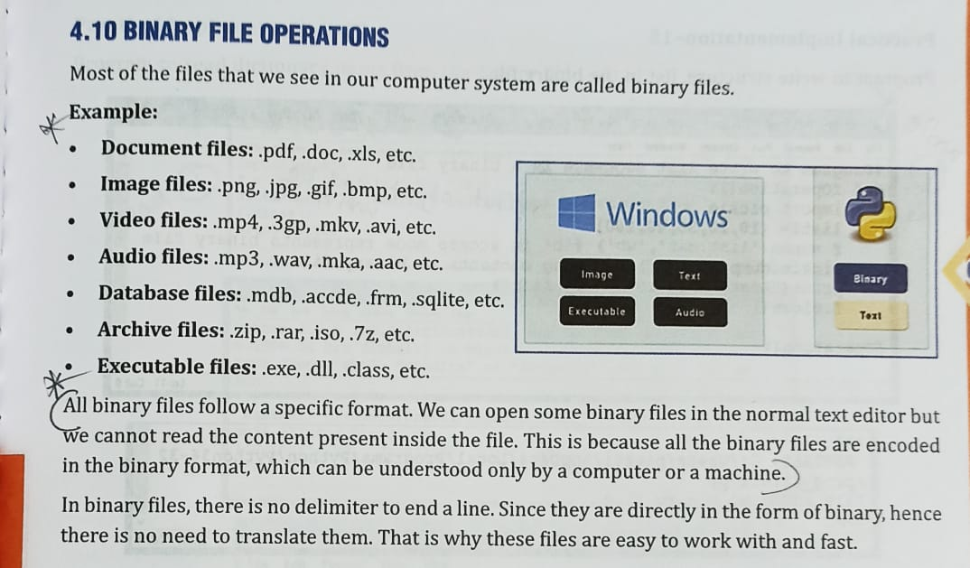

**pickle module: (Python built-in / system defined module)**

For binary file programming we need pickle module.

**Why we need pickle module?**

Python pickle module is used for writing/serializing/pickling and reading/de-serializing/un-pickling python object structures(list, tuple, string, dictionary) to and from a binary file

pickle module contains load( ) and dump( ) functions. load( ) function is used to read(de-serializing/un-pickling) record from binary file , and dump( ) function is used to write(serializing/pickling) data record into binary file. So for writing program on binary file, we need to import pickle module.

**a record = a list / tuple / dictionary - of data

**Pickling and Unpickling :**

Python pickle module is used for serializing(pickling) and de-serializing(unpickling) python object(list, tuple, string, dictionary) structures.

**Pickling:**The process to convert any kind of python objects (list, tuple, string, dict, etc.) into byte streams (0s and 1s) is called pickling or serialization or flattening or marshalling.

**pickling is used to write data in binary file, dump( ) – method is used for pickling data to binary file

**Unpickling:**The process to convert the byte stream(0s and 1s) (generated through pickling) back into python objects(list, tuple, string, dictionary) by a process called as unpickling/de-serializing.

**un-pickling is used to read data in binary file, load( ) – method is used for pickling data to binary file

**Importing pickle module in a python program :**

Code - import pickle

**Functions of pickle module :**

**(i) load( )** – load( ) function of pickle module is used to de-serialize/unpickled byte stream(0s and 1s) into python object(list, tuple, string, dictionary)

**\*\*load( ) function is used to read data record from a binary file. This function works with “rb” mode. This function returns data from file into list form.**

**Code :**

**rec = pickle.load( fobj )**

**print( rec ) / print( rec[0], rec[1], rec[2] )**

**(ii) dump( )** – dump( ) ) function of pickle module is used to serialize/pickled an python object(list, tuple, string, dictionary) structure hierarchy into byte stream(0s and 1s).

**\*\*dump( ) function is used to write/append data into a binary file. This function works with “wb” or “ab” mode.**

**Code :**

**rec = [ 32, “David”, 89 ]**

**pickle.dump ( rec,fobj )**